**COUNTRY AGRO LOGISTICS (PVT) LTD**

**COMPANY PROFILE**

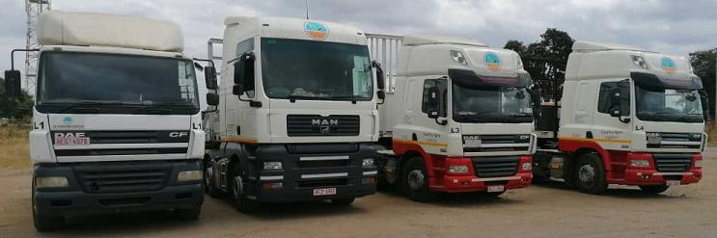

Table of Contents

**1.COMPANY NAME** 3

**1.1 CONTACT DETAILS** 3

**1.2 COMPANY BACKGROUND** 3

**2. COMPANY STRUCTURE** 4

**3. CORPORATE OVERVIEW** 4

**4.OUR FLEET** 6

**5. TRADE REFERENCES** 8

**6. BANKERS** 9

## 

## **1.COMPANY NAME**

Country Agro Logistics (Pvt) Ltd.

## **CONTACT DETAILS**

Contact Name : Tatenda Sayi-Admin Officer

|  |  |
| --- | --- |
| Physical Address | : 70 Mutare Road, Msasa |
| Registered Address | : 39 Wawick Road Greystone Park, Harare |
| Storage Address | : 2 Finneran road, Ardbennie, Harare |
| Phone | : +263 775 880 756; +263 732 328 671 |
| Email | : [brian@countryagrotobacco.co.zw;](mailto:brian@countryagrotobacco.co.zw) [admin@moneymaker.co.zw](mailto:admin@moneymaker.co.zw) |

**COMPANY REGISTRATION NUMBER** **DATE OF INCORPORATION**

22378/2021 14 December 2021

## **1.2 COMPANY BACKGROUND**

Country Agro Logistics (Pvt) Ltd is a privately owned Zimbabwean logistics company.We aim to become a preferred partner in local conveyance of goods to and from any destination in Zimbabwe. Country Agro Logistics has assembled a logistic Team, (operations, drivers, assistant drivers accountant), and complimentary administration team, with vast experience, most having worked for the major multinational companies. We have 13 employees altogether including the drivers, assistant drivers, operations and administration.

We strive to build relationships with our clients, persistently achieving an understanding of their current, as well as future requirements. Country Agro International has modern, well maintained, trucks and trailers arriving on time to pick up or deliver the cargo.

For customers’ peace of mind, the vehicles:

* Have Full Comprehensive Insurance cover
* Have adequate Goods in Transit insurance cover
* are fitted with satellite tracking system, monitored in-house as well as 24-hour cell phone contact when on the road.

Our drivers are:

* Highly experienced holders of Defensive Driving Certificates,
* all well trained in transporting different commodities including food stuffs, live poultry, specialised equipment and hazardous materials
* Uphold high service standards required to satisfy our customers.

## **2. COMPANY STRUCTURE**

## **3. CORPORATE OVERVIEW**

**Vision**

To be the preferred and repeatedly chosen company in the provision of transport services to various sectors of the economy including, but not limited to; manufacturing, agriculture, humanitarian assistance.

**Mission**

To provide total transport solutions centered on upholding a reputation of reliable, safe, timeous and cost effective delivery of cargo for our clients.

**Values**

* Customer satisfaction
* Safety for cargo at all costs
* Integrity and self-improvement

**INDUSTRY EXPERIENCE**

**Humanitarian/N.G.O. sector**

Country Agro Logistics (Pvt) Ltd has experience in delivering humanitarian food assistance within rural areas, having worked with **World Vision Zimbabwe** in Mudzi District in 2020.

**Agriculture Sector**

* **Transporting live poultry and stockfeed:**
* Stockfeed to Irvines’ farms and numerous Irvines contracted out grower farms spread around Harare, Mashonaland East and Mashonaland West provinces.
* Live poultry from numerous Irvines contracted out grower farms spread around Harare, Mashonaland East and Mashonaland West provinces.
* **Hauling grain harvest:**
* Maize from Mashonaland East and Manicaland provinces to G.M.B. Harare and DELTA Corporation Chitungwiza.
* Barley from Mashonaland East and Manicaland provinces to DELTA Corporation

Kwekwe malting plant.

-Wheat from Mashonaland East and Manicaland provinces to G.M.B. Harare and Norton.

* **Hauling bird’s eye chilli:**
* From the Lowveld; Chiredzi, Gonarezhou, Middle Sabi
* From Gokwe in Midlands province.
* **Distribution of inputs** i.e. seedlings, fertilizers, chemicals and packaging materials to small scale farmers has been undertaken for the following companies;
* **Mectrig Investments (Pvt) Ltd**
* **Petrana Trading (Pvt) Ltd – Bindura Tobacco**
* **HILART INVESTMENTS (Pvt) Ltd T/A KACHOLO CHILLIES**
* **Zimbabwe Phosphate Industries**
* Country Agro Logistics provided the following transport services **to Consolidated Tobacco Processors**, helping them reduce costs while providing an efficient service:
* Carting green tobacco from the three auction floors, and several contract floors to warehouses
* Moving both green and packed tobaccos from inter- company sales
* Transportation of packed tobacco from processing plant to warehouses undertaken for **Victory Risk Services, Shasha Tobacco, Voedsel Tobacco International**
* Transportation of other goods i.e. Irrigation Equipment, Furniture for various companies to different destinations.

## **4. OUR FLEET**

Our fleet includes 7-ton, 10 ton, 15 ton, 20 ton and 30 ton trucks. Truck and trailer bodies range from curtain sides, drop sides and flat decks. We continue to invest in our fleet to ensure we have the most efficient and reliable vehicles to ensure that we deliver on time, in full and hassle free.

**FLEET**

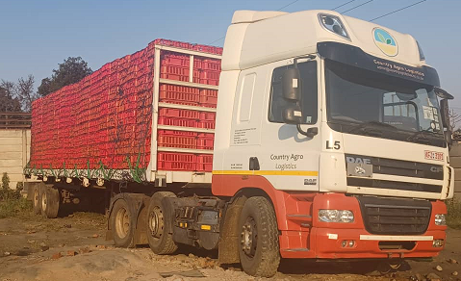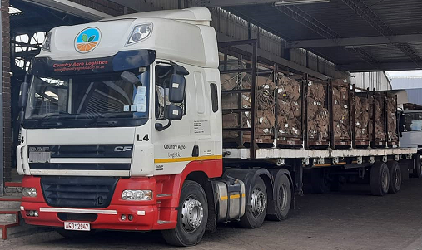 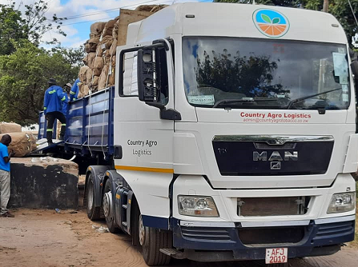 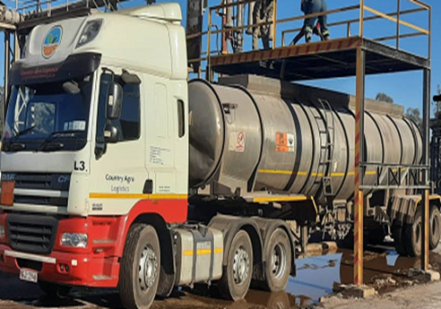

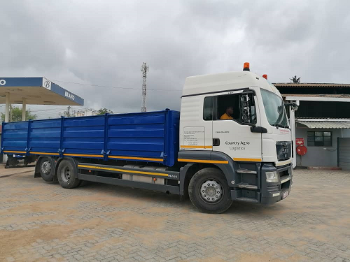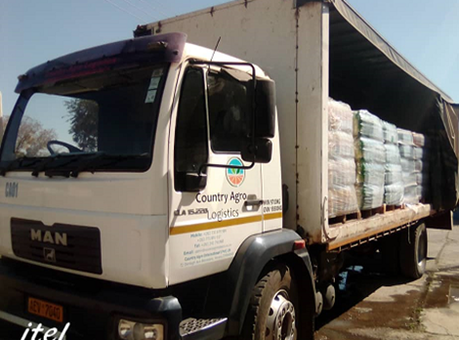

## **5. TRADE REFERENCES**

**IRVINES CHICKENS**: Hardie Chemaka

|  |  |  |  |  |  |
| --- | --- | --- | --- | --- | --- |
| Address | : Henley drive extension, Waterfalls, Harare. | | | | |
| Phone | : +263 772 916 296; 08677006080 |  |  |  |  |
| Email | :hardie@irvines.co.zw | | | | |
| Product | : - Stock feed to Irvines’ and out grower farms and live poultry from out grower farms | | | | |

**WORLD VISION ZIMBABWE**: Teererai Chikukwa, Never Chituwu, Hamunyari Madziwana

|  |  |  |  |  |  |
| --- | --- | --- | --- | --- | --- |
| Address | : No 59 Joseph Road/Off Nursery Road Mt Pleasant. | | | | |
| Phone | : +263 774 072 717 |  |  |  |  |
|  |  | | | | |
| Email | [:Never_Chituwu@wvi.org,Hamunyari](mailto:Never_Chituwu@wvi.org,Hamunyari) [Madziwana@wvi.org](mailto:Madziwana@wvi.org) | | | | |
| Product | : -Food commodities i.e. cereals, pulses, vegetable oil from Mudzi | | | | |
|  | Warehouse to designated areas within Mudzi District | | | | |
| **ZIMBABWE PHOSPATE INDUSTRIES Ltd**: Nelson Mhlanga   |  |  |  |  |  |  |  |  | | --- | --- | --- | --- | --- | --- | --- | --- | | Address | : Off Mutare road, Msasa. Harare | | | | | | | | Phone | : +263 773 840 577 |  |  |  | | |  | | Email | : mhlangan@zimphos.co.zw | | | | | | | | Product | : Fertilizers, Chemicals | | | | | | | | **HILART INVESTMENTS (Pvt) Ltd T/A KACHOLO CHILLIES** : Kelsey Wood | | | | | | | | | Address | : 14279 Tomlinson Avenue. Gunhill. Harare | | | | | | | | Phone | : +263 0772302252 |  |  |  | | |  | | Email | :kelsey@kacholo.com | |  |  | | |  | | Product | : -Bird’s eye chilies from Chiredzi, Birchnough and Gokwe, Inputs | | | | | | | |  | i.e. fertilizers /seedlings to farmers | |  |  | | |  | |  | | | | |  | | **BINDURA TOBACCO T/A PETRANA (PVT)LTD** | | | **:** Mr Matayaunga | | | | | | Address | : 70 Mutare Road ,Msasa,Harare | | | | | | | | Phone | : +263 772 224 827 |  |  |  | | |  | | Email | mmatayaunga@bt.co.zw | |  |  | | |  | | Product | : -Tobacco from sales floors to warehouses | | | | | | | |  | -Inputs i.e. Fertilizers, Chemicals, packaging to growers | | | | | | | | | | | | |

## **BANKERS**

* + **ECOBANK**
  + **FBC BANK**
  + **NEDBANK**